SIMATS ENGINEERING
ASSESSMENT TOOL 2

COURSE NAME: INTERNET PROGRAMMING
COURSE CODE: CSA43

COURSE OUTCOME COVERED

CO-1: Develop well-structured, standards-compliant web pages using HTML/XHTML and XML, and apply Internet protocols and HTTP communication mechanisms for web content delivery. (L2)

Assessment Tool : Data Interpretation

Weightage: 20%

QUESTIONS: Total Marks: 20

1: HTTP Response Analysis
A web server returns the following HTTP response header:
HTTP/1.1 200 OK
Date: Mon, 01 Apr 2026 10:00:00 GMT
Content-Type: text/html
Content-Length: -150
Connection: keep-alive
Questions:
1.Identify any incorrect or invalid fields in the header.
The incorrect field is Content-Length: -150. The content length cannot be negative. The date header also needs verification because the weekday and calendar date may not match.

2..Analyze the issue with Content-Length and explain its impact.

The Content-Length header specifies the size of the response body in bytes. A negative value is invalid and may cause parsing errors, incorrect response handling, or communication problems between the browser and server.

3.Determine whether the status code matches the response correctness.

The status code 200 OK indicates that the request was successful. However, the invalid Content-Length makes the response header incorrect. Therefore, a successful status code does not guarantee that every response header is valid.

4.Suggest corrections for the identified errors.
• Set Content-Length to the actual non-negative size of the response body.
• Verify and correct the date header.
• Retain HTTP/1.1 200 OK if the request was successful.
• Ensure all headers follow HTTP standards.
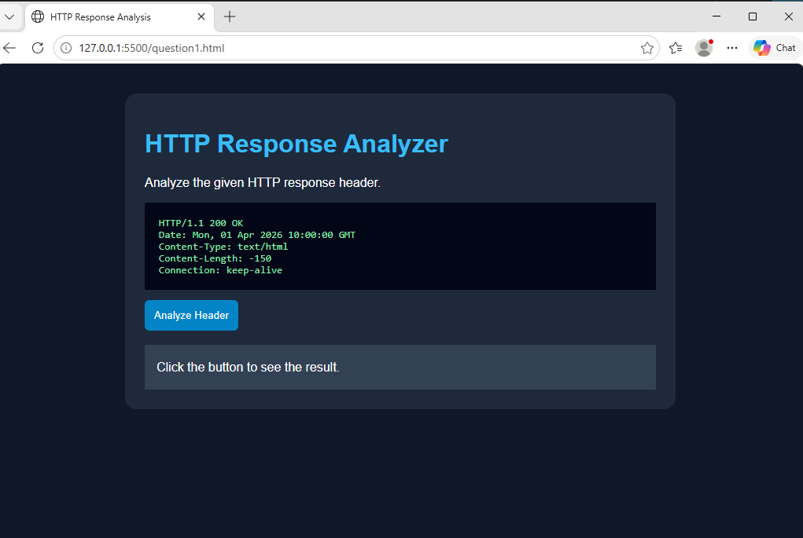
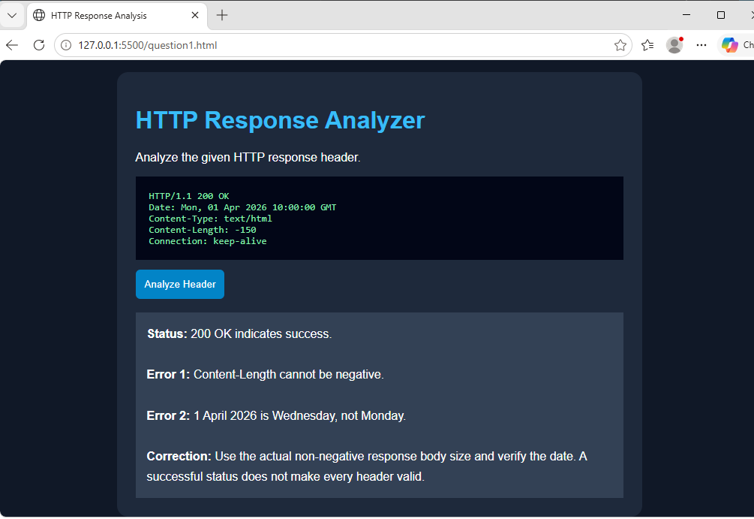
2: DOM Structure Analysis
Consider the following DOM tree representation:
<html>
<head>
<title>Test Page</title>
</head>
<body>
<div>
<p>Hello World
</div>
</body>
</html>
Questions:
1.Identify missing or improperly closed elements.
The <p> element is missing its closing </p> tag. The <div> element and other outer elements have closing tags.

2.Analyze how the browser will interpret this structure.

The browser's HTML parser will usually automatically close the paragraph when it encounters the closing </div> tag. It will attempt to construct a usable DOM tree even though the original markup is incomplete.

3.Determine the impact on rendering and layout.

The page may still display the text “Hello World,” but the browser may correct the structure automatically. Invalid or incomplete markup can cause unexpected spacing, layout differences, and inconsistencies in document structure.

4.Suggest corrections to make the DOM valid.
<!DOCTYPE html>
<html>
<head>
<title>Test Page</title>
</head>
<body>
<div>
<p>Hello World</p>
</div>
</body>
</html>
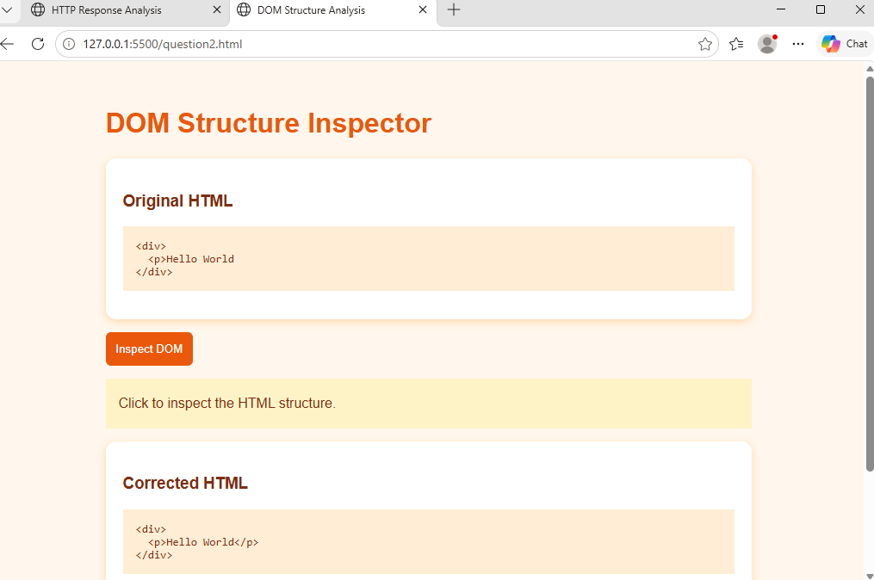
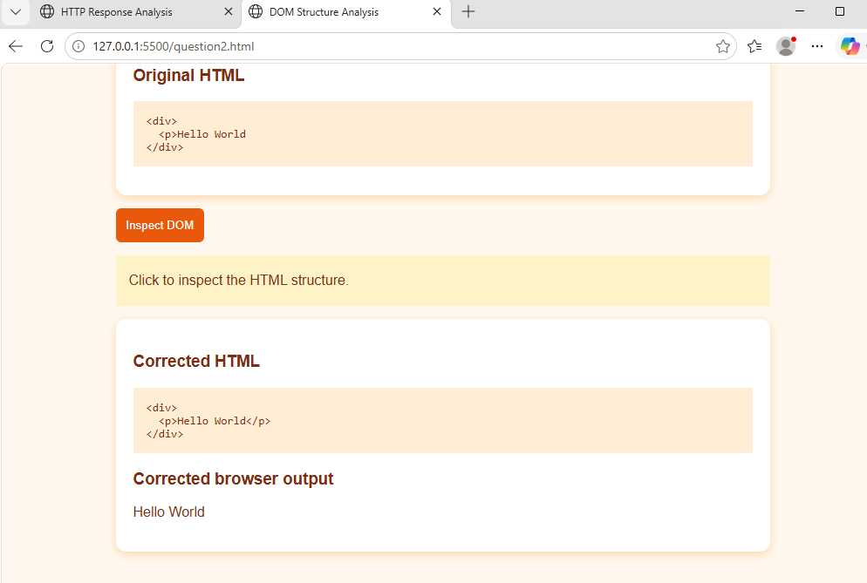

3: GET vs POST in Login System
A login system uses two different methods:
Method | URL Example | Data Visibility | Security Level
GET | /login?user=admin&pass=1234 | Visible in URL | Low
POST | /login | Hidden in body | Moderate
Questions:
1.Interpret the differences in data transmission between GET and POST.
GET sends data through the URL as query parameters, making the information visible in the address bar. POST sends data in the request body, so the submitted data is not normally visible in the URL. Both methods require HTTPS to protect information during transmission.

2.Analyze which method is more suitable for login and why.

POST is more suitable for login systems because usernames and passwords are not included in the URL. It reduces the risk of credentials appearing in browser history and URL logs. However, POST alone does not provide security; HTTPS and proper authentication controls are essential.

3.Identify security risks in using GET for authentication.

• Passwords may appear in browser history.
• URLs may be recorded in server logs.
• Sensitive information may be exposed through shared links.
• URLs may be stored in monitoring systems or other records.
• Credentials may be exposed if HTTPS is not used.

4.Suggest best practices for secure login implementation.
• Use POST for submitting login credentials.
• Use HTTPS to encrypt communication.
• Store passwords using secure password hashing.
• Implement multi-factor authentication when appropriate.
• Use secure session cookies and rate limiting.
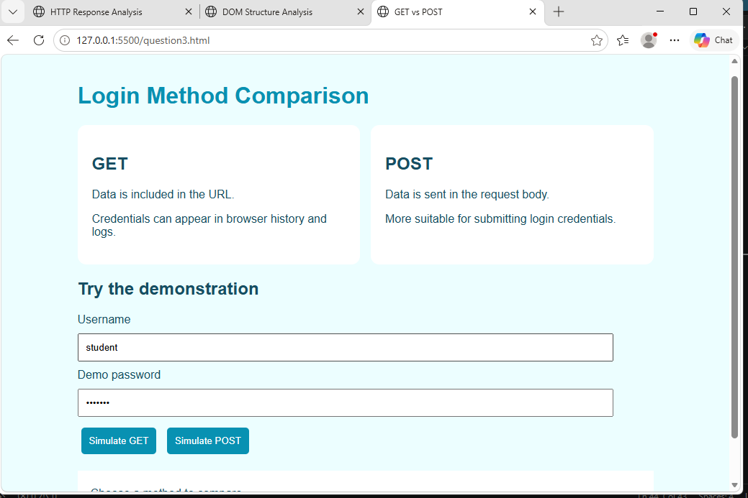
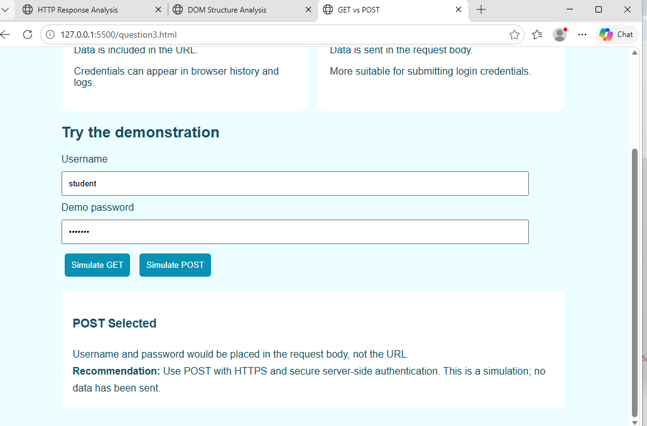

4: HTML Code Inspection
Analyze the following HTML snippet:
<!DOCTYPE html>
<html>
<head>
<title>Sample</title>
</head>
<body>
<h1>Welcome
<p>This is a paragraph
<img src="image.jpg">
</body>
</html>
Questions:
1.Identify missing closing tags.
The <h1> and <p> elements are missing their closing tags, </h1> and </p>. The <img> element is a void element, so it does not require a closing tag in HTML5.

2.Analyze issues with the <img> tag.

The image tag does not include an alt attribute. Alternative text improves accessibility and provides a text description when the image cannot be displayed.

3.Determine how browsers will handle these errors.

Browsers generally attempt to repair malformed HTML automatically. The page may still display, but the resulting DOM structure and layout may not match the developer's intention. Missing alternative text also reduces accessibility.

4.Suggest a corrected version of the code.
<!DOCTYPE html>
<html>
<head>
<title>Sample</title>
</head>
<body>
<h1>Welcome</h1>
<p>This is a paragraph.</p>
<img src="image.jpg" alt="Sample image">
</body>
</html>

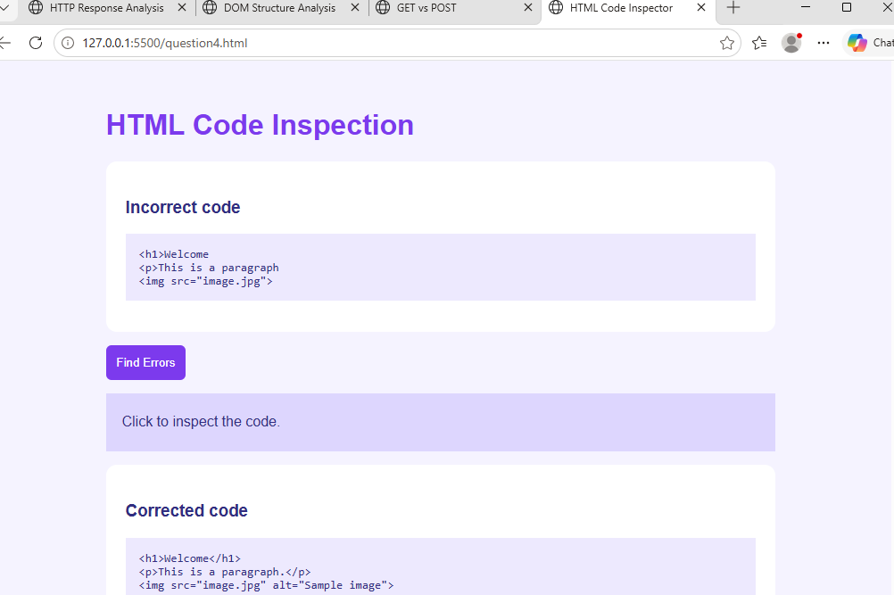
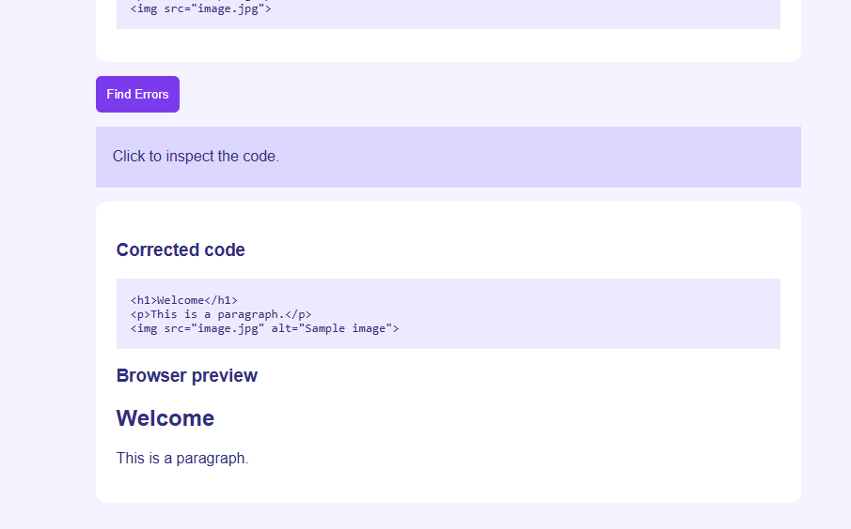

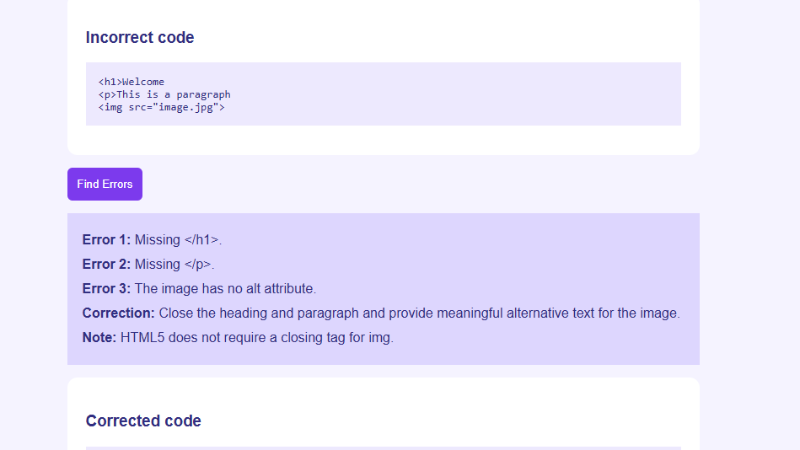

5: Browser-Server Communication Flow
The following sequence describes a web request:
- User enters a URL in the browser
- DNS lookup occurs
- HTTP request is sent
- Server processes request
- Response is returned
- Browser renders page
Questions:
1.Interpret each step in the communication flow.
• User enters a URL: The user types a website address into the browser.
• DNS lookup occurs: DNS translates the domain name into an IP address.
• HTTP request is sent: The browser establishes the required connection and sends an HTTP request to the server.
• Server processes the request: The server processes the request and retrieves or generates the required content.
• Response is returned: The server sends an HTTP response containing a status code, headers, and possibly a response body.
• Browser renders the page: The browser interprets HTML, applies CSS, executes JavaScript, and displays the page.

2.Identify where delays can occur.

Delays may occur during DNS resolution, connection establishment, TLS negotiation, network transmission, server-side processing, database queries, and downloading or rendering large resources.

3.Analyze the role of DNS in the process.

DNS (Domain Name System) translates human-readable domain names, such as www.example.com, into IP addresses that computers use to locate servers. DNS caching can reduce repeated lookups and improve website loading speed.

4.Suggest optimizations to improve performance.
• Use DNS caching to reduce lookup time.
• Optimize images and compress web resources.
• Use HTTP caching to avoid unnecessary downloads.
• Optimize server code and database queries.
• Use a Content Delivery Network (CDN) to serve content closer to users.
• Minimize unnecessary HTTP requests and use modern HTTP protocols where appropriate.
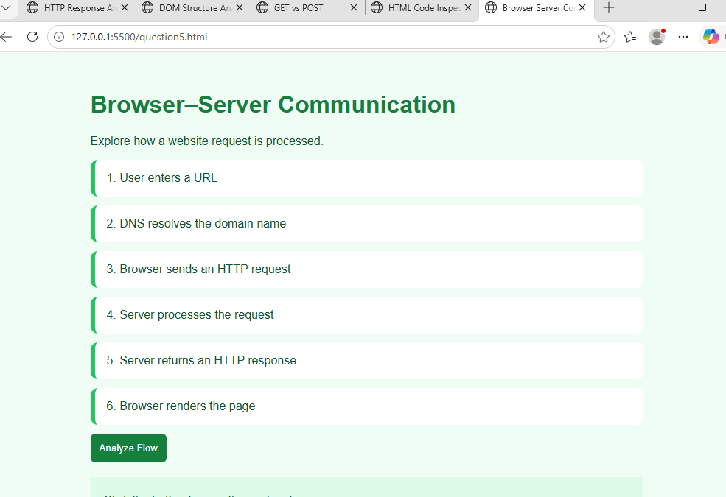

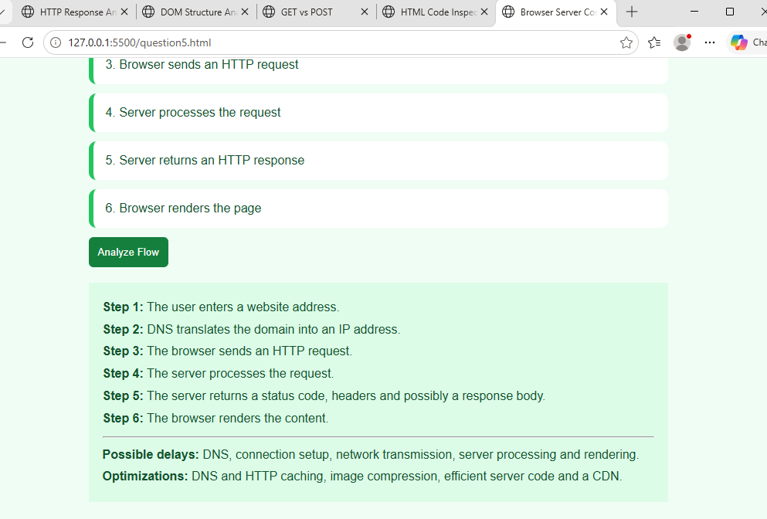

Code of Conduct:

I ____________________ (Name / Reg No) certify that this submission is my original work and that I have adhered to the guidelines specified for this assessment.
I understand that any violation of academic integrity rules will result in disciplinary action.

Signature of the student:

RUBRICS FOR CALCULATION:

Criteria | Weightage | Level 4 (Exemplary) | Level 3 (Proficient) | Level 2 (Developing) | Level 1 (Beginning)
Understanding of Data | 25% | Accurately interprets all data patterns, trends, and relationships | Interprets data correctly with minor gaps | Partial understanding; misses key trends | Misinterprets or fails to understand data
Analysis | 25% | Provides deep analysis with strong logical reasoning and justification | Provides reasonable analysis with some justification | Basic analysis with weak reasoning | No meaningful analysis provided
Application of Concepts | 20% | Effectively applies relevant concepts/tools to interpret data accurately | Applies concepts with minor errors | Limited application; requires guidance | Unable to apply concepts to data
Conclusion | 20% | Draws clear, meaningful conclusions with strong insights and implications | Provides valid conclusions with moderate insights | Conclusions are vague or weak | No clear or valid conclusions
Clarity | 10% | Presents interpretation clearly using proper structure, visuals, and terminology | Generally clear with minor issues | Lacks clarity or proper structure | Poor presentation and difficult to understand

